**Collection Running along with variables using Newman:**

Open the postman and select the collection we want to execute click on the three dots and select export and export to the folder.

Same like collection open environment variables and export to the folder.

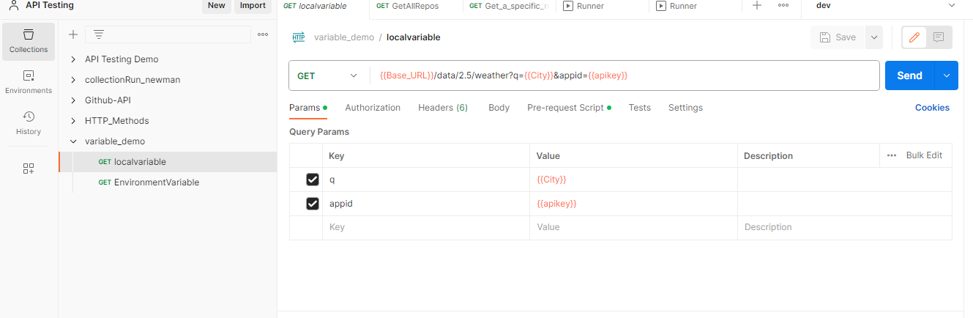

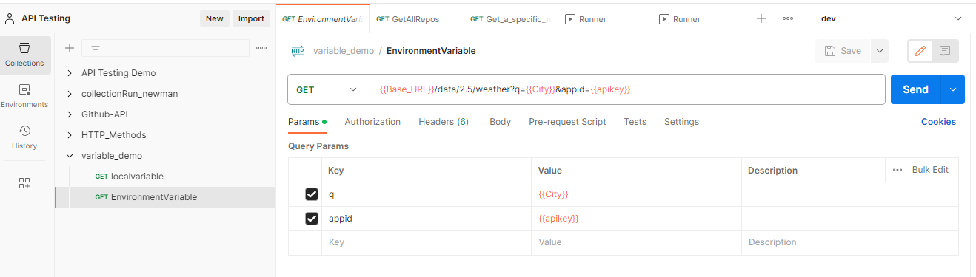

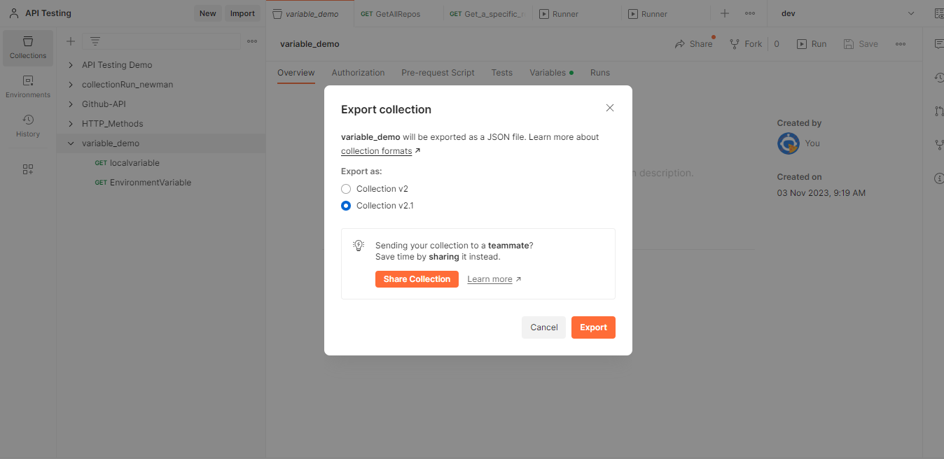

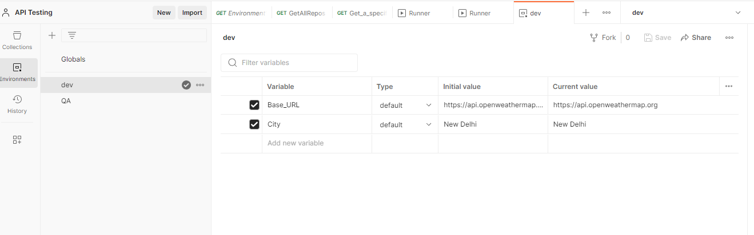

And the files are exported to the folder as given below.

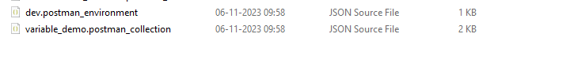

And open the command prompt on the folder and execute the below command

# newman run <filename>.json -e < environment variable>.json

